Order of Mission
Mission:
Set up:

Inventories Check List

Cat |  | Quantity | Before | Quantity | After | Quantity | Remark
Camera | Canon 80 D#1
Camera | Canon 80 D#2
Camera | Canon 80 D#3
Camera | Canon 6D
Camera | Go Pro
Cable | Cable to charge the GoPro
Camera | OSMO
Batteries | Batterie for Osmo
Charger | Osmo batterie charger
Zoom | Canon
Flash | Canon Speedlite 430EX II
Light | On camera Led light - Sevenoak
Batteries | Canon batteries #1
Batteries | Canon batteries #2
Batteries | Canon batteries #3 |  |  |  |  |  |  | Batteries | Canon batteries #1
Batteries | Canon batteries #4
Batteries | Canon batteries #5
Batteries | Canon batteries #6
Batteries | Canon batteries #7
Batteries | AA Sennheiser Batteries (Need 4+4)
Batteries | LED Lamps Batteries #1 |  |  |  |  |  | Need 2 per lamp
Batteries | LED Lamps Batteries #2
Batteries | LED Lamps Batteries #3
Batteries | LED Lamps Batteries #4
Batteries | LED Lamps Batteries #5
Batteries | LED Lamps Batteries #6
Sound | Sennheiser microphone
Sound | 360 cable Microphone
SD Cards | #1
SD Cards | #2 64GB
SD Cards | #3 32GB
SD Cards | #3 64GB
SD Cards | #4
SD Cards | #5 64GB
SD Cards | #6 64GB
SD Cards | SDHC 16GB
Tripods | Tripod camera 80D #1
Tripods | Tripod camera 80D #2
Tripods | Tripod lamps #1
Tripods | Tripod lamps #2
 | Pack lights (with feet)
Charger | Canon Battery Charger #1
Charger | Canon Battery Charger #2
Charger | Canon Battery Charger #3
Charger | Canon Battery Charger #4
Charger | AA battery charger
Microphone set | Microphone kit. 5 ELEMENTS (receiver, recorder, attach board, cable, mic) |  |  |  |  |  | 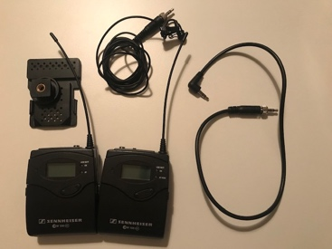
Microphone set | Earphone (big one with adapter)
Microphone set | Small earphone
Adaptor | Apple cable
Adaptor | HDMI cable
Other | Slider

In charge

